TIMESHEET CALCULATOR v2 MANUAL

SUMMARY
- Introducing the files -------------------------------------------------------------------------------------- 2
- Typical Workflow ----------------------------------------------------------------------------------------- 4
  - Loading the excel files in the input folder ------------------------------------------------------ 4
  - Launching the application ------------------------------------------------------------------------- 5
  - Generating the output file -------------------------------------------------------------------------- 5
  - Checking the timesheet calculation output file ----------------------------------------------- 6
- Changing the holidays for the year ------------------------------------------------------------------ 7
- Using the Employee Timesheet Template --------------------------------------------------------- 9
  - Adding Employee Information -------------------------------------------------------------------- 9
  - Adding Task Information --------------------------------------------------------------------------- 9
  - Saving the document ------------------------------------------------------------------------------ 11

INTRODUCING THE FILES

- Go to the main folder by double-clicking on the “Timesheet Calculator v2” Folder.

- After accessing the main folder, it’s contents will look something like this:

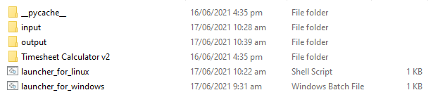

- The “input” folder is where the employee timesheets will be placed. The expected files should be in the excel (.xlsx) file format.

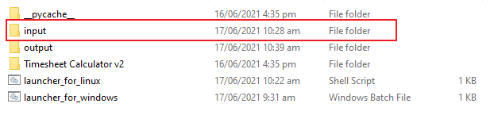

- Example employee timesheets. (Warning: Only the timesheet template provided will work on this tool).
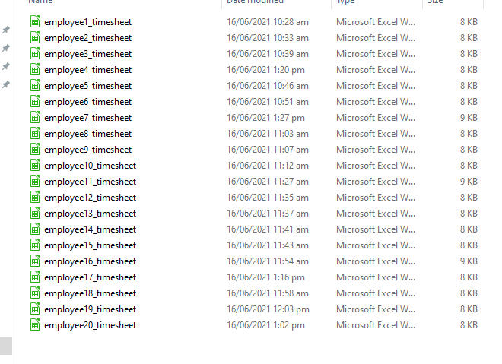

- The “output” folder is where the timesheet calculation will be generated. It has an excel (.xlsx) file format.

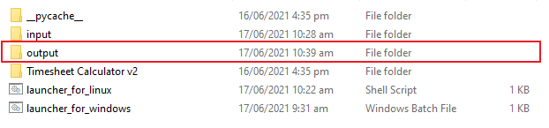

- The “Timesheet Calculator v2” is the main folder for the source code. You will only access this if you want to change the HOLIDAYS of the year. This will be discussed later.

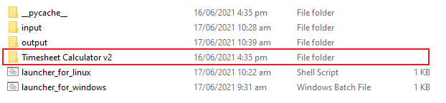

- The two remaining files are the launchers for the tool (Timesheet Calculator v2). “launcher_for_linux” is used to launch the application in a Linux machine/Computer. “launcher_for_windows” is used to launch the application in a Windows machine/Computer.

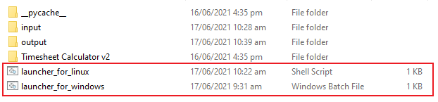

TYPICAL WORKFLOW

The typical way to use the application is to first load the data (excel files) in the “input” folder, launch the application, generate the output and the resulting files will be in the “output” folder.

- Loading the excel files in the input folder:
  - Copy the all the desired timesheet files you need for generation. To copy, highlight all the files and right-click and choose copy. (Warning: Only the timesheet template provided will work on this tool)

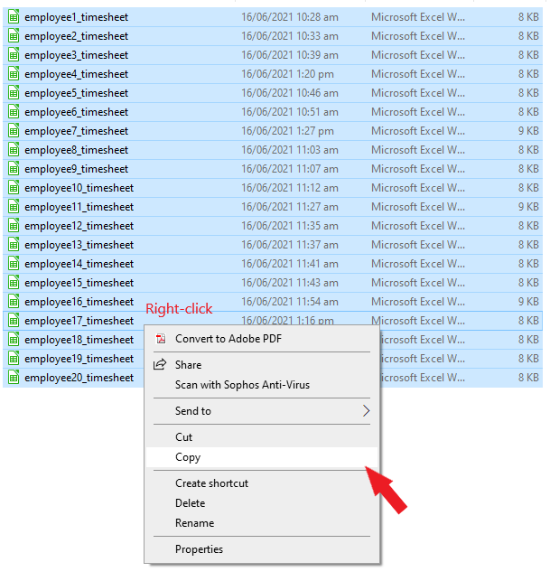

  - Paste it on the “input” folder by pressing Ctrl + v.
- Launching the application:
  - Double-left-click the “launcher_for_windows” if you’re using a Windows machine. Or Double-left-click the “launcher_for_linux” if you’re using a Linux machine. After that a window will appear similar to this:

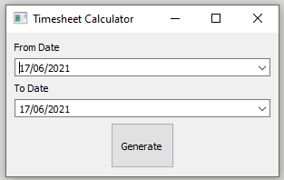

- Generating the output file:
  - Pick the date range that you want to generate.

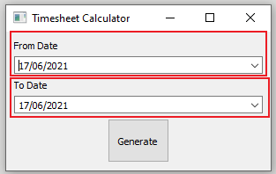

  - You can modify the From Date value either by editing the date directly or clicking the arrow button on the right most side then choose the specific date in the calendar. (Note: From date must be before To date)

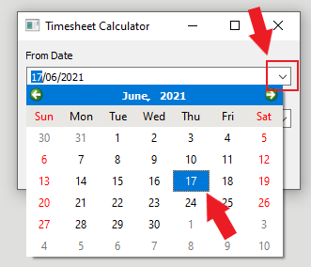
  - After you have chosen the desired range dates, you can now generate the output by clicking on the “Generate” button. A progress window will appear, wait until its finished, then click “Close” button.

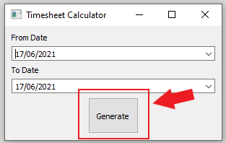

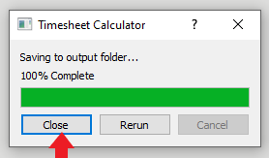

- Checking the Timesheet calculation output file:
  - If everything works correctly, the output file will be in the “output” folder.
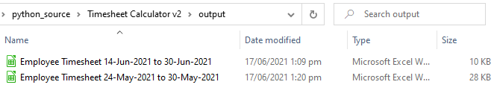

CHANGING THE HOLIDAYS FOR THE YEAR

We need change the holidays every start of the year since the holidays might affect the tool’s final computation of hours. Timesheet Calculator v2 uses the holiday.csv file to store the holidays for the year. CSV file is short for Comma Separated Value, it is a lightweight file formatting that is used for software configuration or even for office application.

- The holiday.csv file can be found here in this directory:
Timesheet Calculator v2\Timesheet Calculator v2\files\holiday.csv
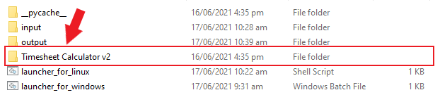

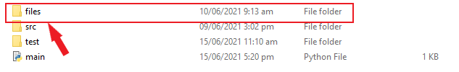

- You can open it using LibreOffice or Excel. Here we will use the LibreOffice application. After opening the CSV file this will contain the following shown in the image below.
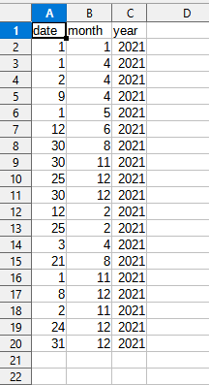
  - Each row is represented by a Holiday date. It’s columns are separated by date, month, year. You can modify/delete the contents in the cell just like in a normal spreadsheet.

USING THE EMPLOYEE TIMESHEET TEMPLATE

The Employee Timesheet Template (for WFH) is specifically used in the Timesheet Calculator Tool to parse and generate the timesheet calculation.

Warning: If you do not use this Template, the tool will not include your timesheet in the calculation.

- Adding Employee Information
  - Input your ID Number, First name, Middle name, Last name in each respective cells.

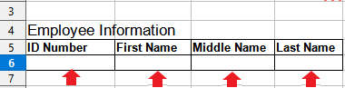

  - ID Number – can be left blank for now. (but will use this later for future automation in employee data management)

- Adding Task Information
  - Each row is represented by a task. This is divided into Date, Time-in, Time-out, Task Name, Project Name.
  - Input each information in their respective cells.

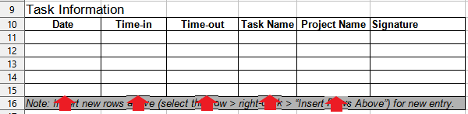

  - Note that date, time inputs are strictly checked. If you input an invalid date or time an error prompt will appear.
  - If you have multiple task in the same day you need to input them separately in rows.

  - To add a new row in the table, right-click on the row number on the left-most side, then click “Insert Rows Above”/”Insert Rows Below” as shown below.

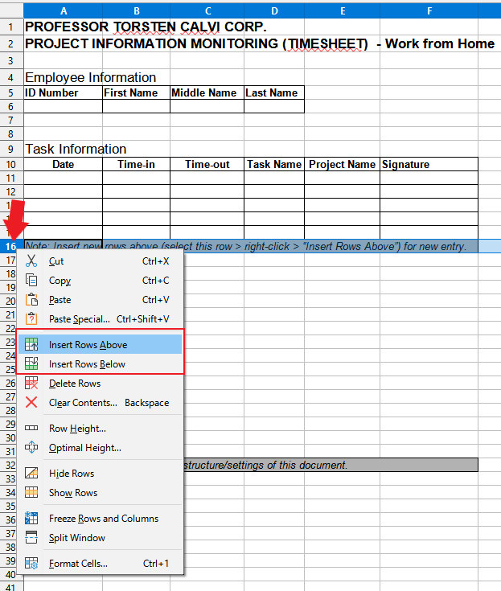

- Saving Document
  - Press Ctrl + S or go to File > Save to save the document.
  - Warning: You must always save it as an Excel File (.xlsx) and NOT LibreOffice File (.ods).

  - 